Build the pedometer app using the step detector sensor.

MainActivity.java : The 'MainActivity' class in the Android pedometer app is designed to handle step counting utilizing the device's step counter sensor. Requesting the 'ACTIVITY_RECOGNITION' permission for Android 10 and higher, controlling the sensor's lifetime with activity state changes, and updating the UI with the step count are all key features. The program manages sensor registration and unregistration efficiently in the 'onResume()' and 'onPause()' methods, and processes sensor data in the 'onSensorChanged()' function. The result of the permission request is handled in 'onRequestPermissionsResult()', ensuring that the app works correctly based on user permissions.

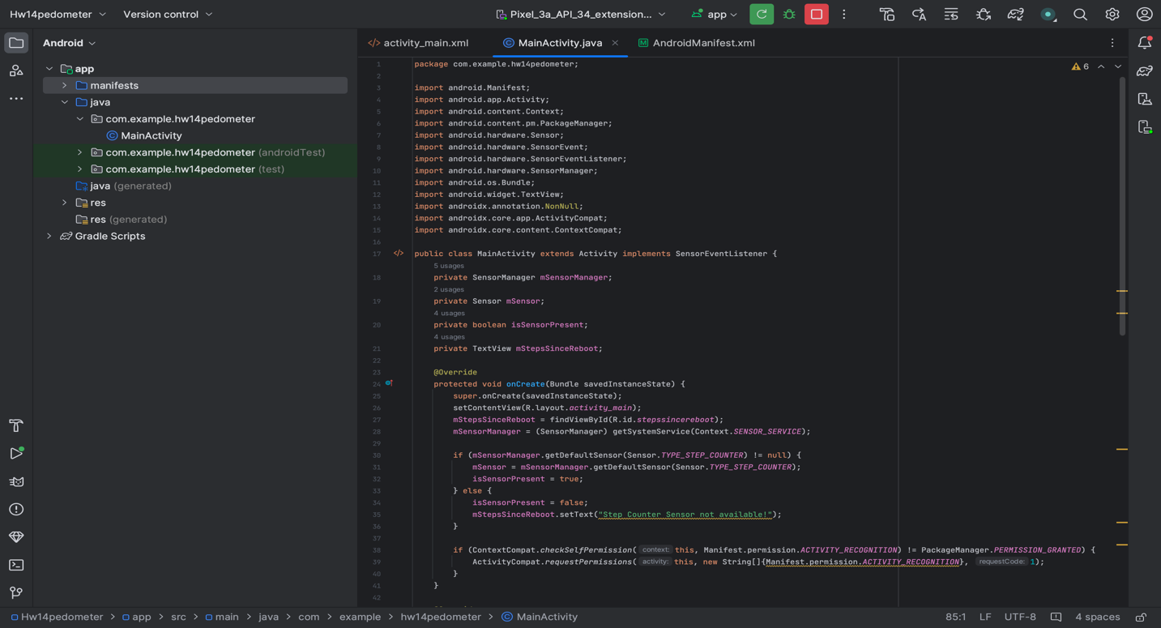

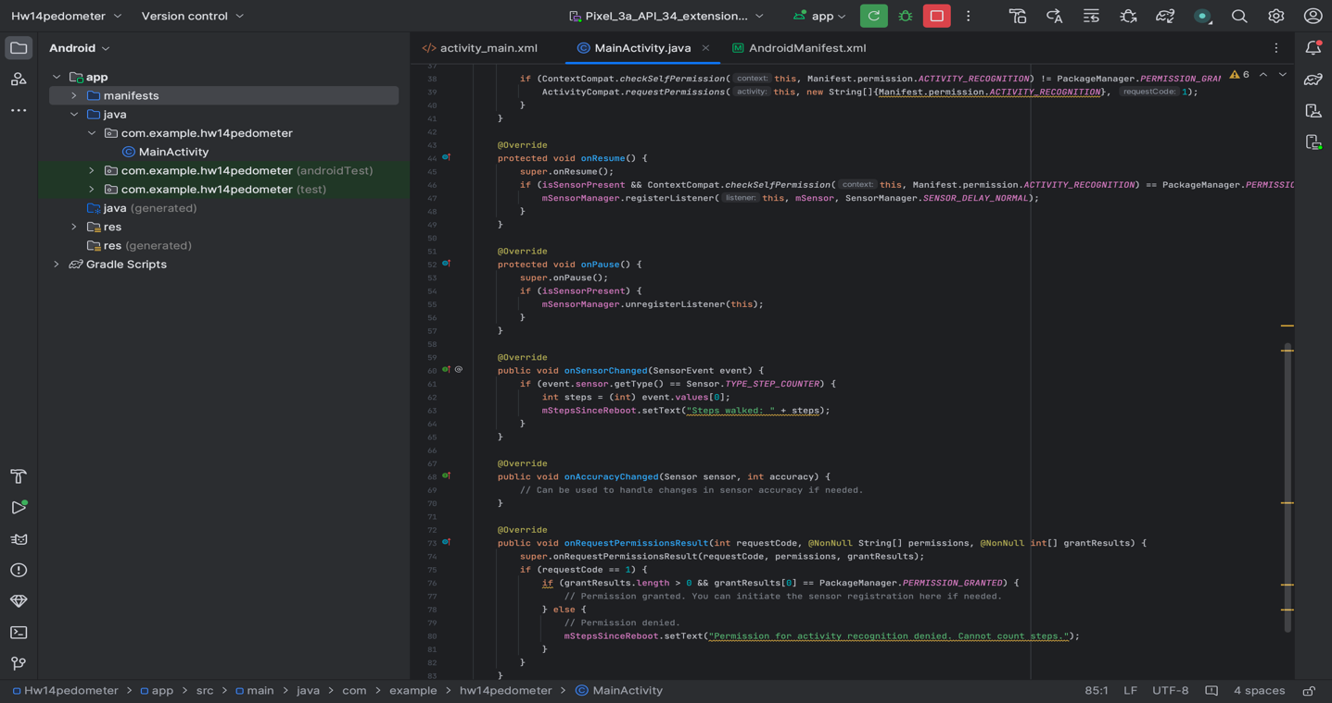
Activity_main.xml : 'ConstraintLayout' is used in this XML layout code to define a minimal user interface for an Android app. It has a single 'TextView' widget in the center of the screen that displays "Steps walked: 0" at first. The 'TextView' is given the ID '@+id/stepssincereboot,' allowing it to be referred to in the app's Java code. The text size is set to 18sp to provide optimum readability on a variety of screen sizes. The use of 'ConstraintLayout' allows for more UI advancements.

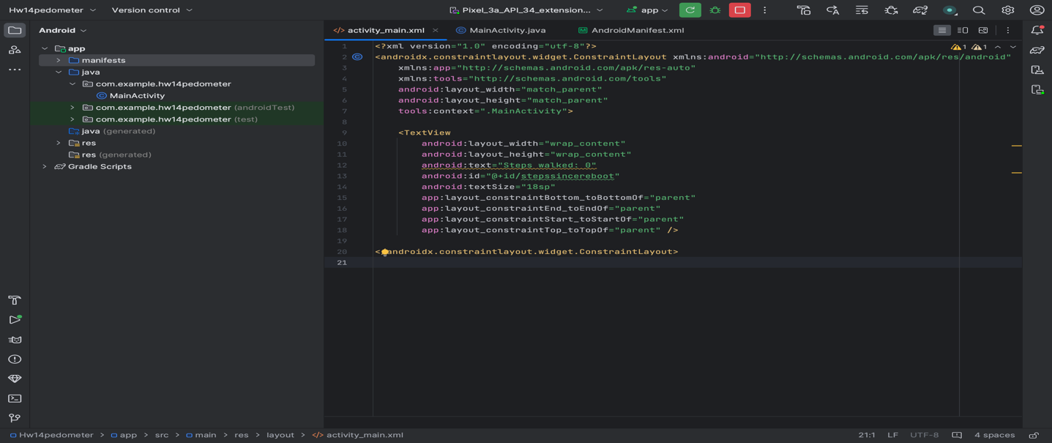

Androidmanifest.xml : This XML segment is the manifest file for an Android application, and it declares important app-level configurations. It has the 'ACTIVITY_RECOGNITION' permission, which is required for obtaining step count data because the app features step counting capabilities, which needs monitoring the user's physical activity. The manifest also specifies the 'MainActivity' as the app's entry point, with an intent filter that launches it as the primary activity. Other settings affect how the program looks and behaves, such as its icon, theme, and compatibility for right-to-left layouts.

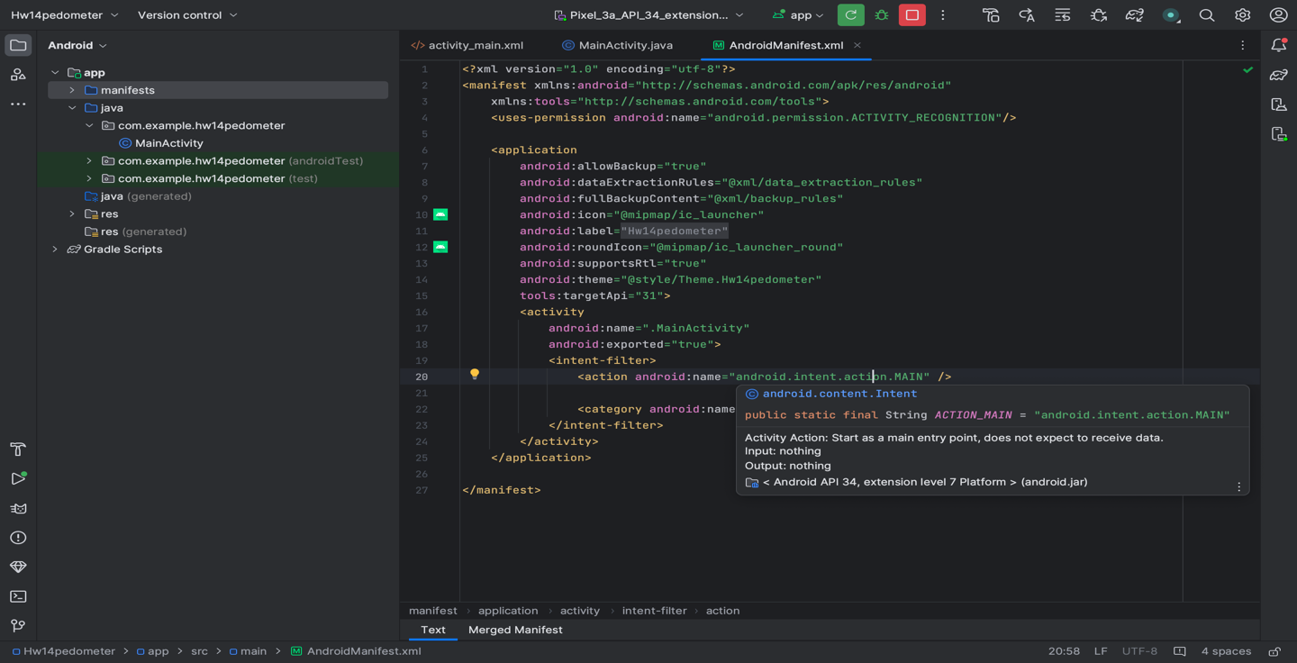

Below are the screenshots of the app :
Note : I ran app on my android device



SS! (Mainactivity with 0 steps) SS2 (Mainactivity after steps walked)

